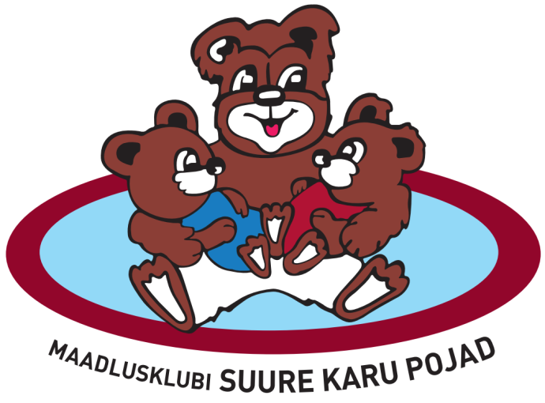
56. vändra OPEN and kids series competition for presidential cup

INVITATION

Time and place: Competition held in 09.04.2022 in Vändra, Kooli 13 (Vändra gümnaasium), ESTONIA.
Competition is in greco-roman style for boys and seniors and women wrestling for girls.

- Weigh-in 08.04.2022 18:00-18:30 and 09.04.2022 9:30-10:00 at the same place.
- Opening ceremony will begin in 10:50
- Competition will start at 11:00

Participants for Vändra Open:
Boys U15 (2007-2010):-38kg, -41kg, -44kg, -48kg, -52kg, -57kg, -63kg, -68kg, -75kg, -85kg
Boys (2009-2010): -70kg
Girls 2005 and younger: -55kg
Seniors: -60kg, -67kg,-77kg, -82kg, -87kg (Seniors have weight allowance +2 kg)
Awarding: Weight winner will get the cup and a diploma, 2nd and 3rd place will get a medal and a diploma.
Participants for the kids series competition for presidential cup:
GIRLS 2011 and younger: -25kg;-30 kg; -35kg;-40 kg; -50 kg ja -76kg
BOYS 2011 and younger: -20 kg, -23 kg, -26 kg, -29 kg, -32 kg, -35 kg,-38 kg, -42 kg, -47 kg, -53 kg, -65kg, -85kg.
Awarding: First 3 are awarded with cups (one third place will be wrestled out)
Participation fee: Deadline for pre-registration is 06.04.2022 and the fee is 10EUR per person. For teams that enter their registration form later the fee is 15EUR per person.
For accomandation please contact Mario Mägisalu (magisalum@gmail.com) or call +37256389434

